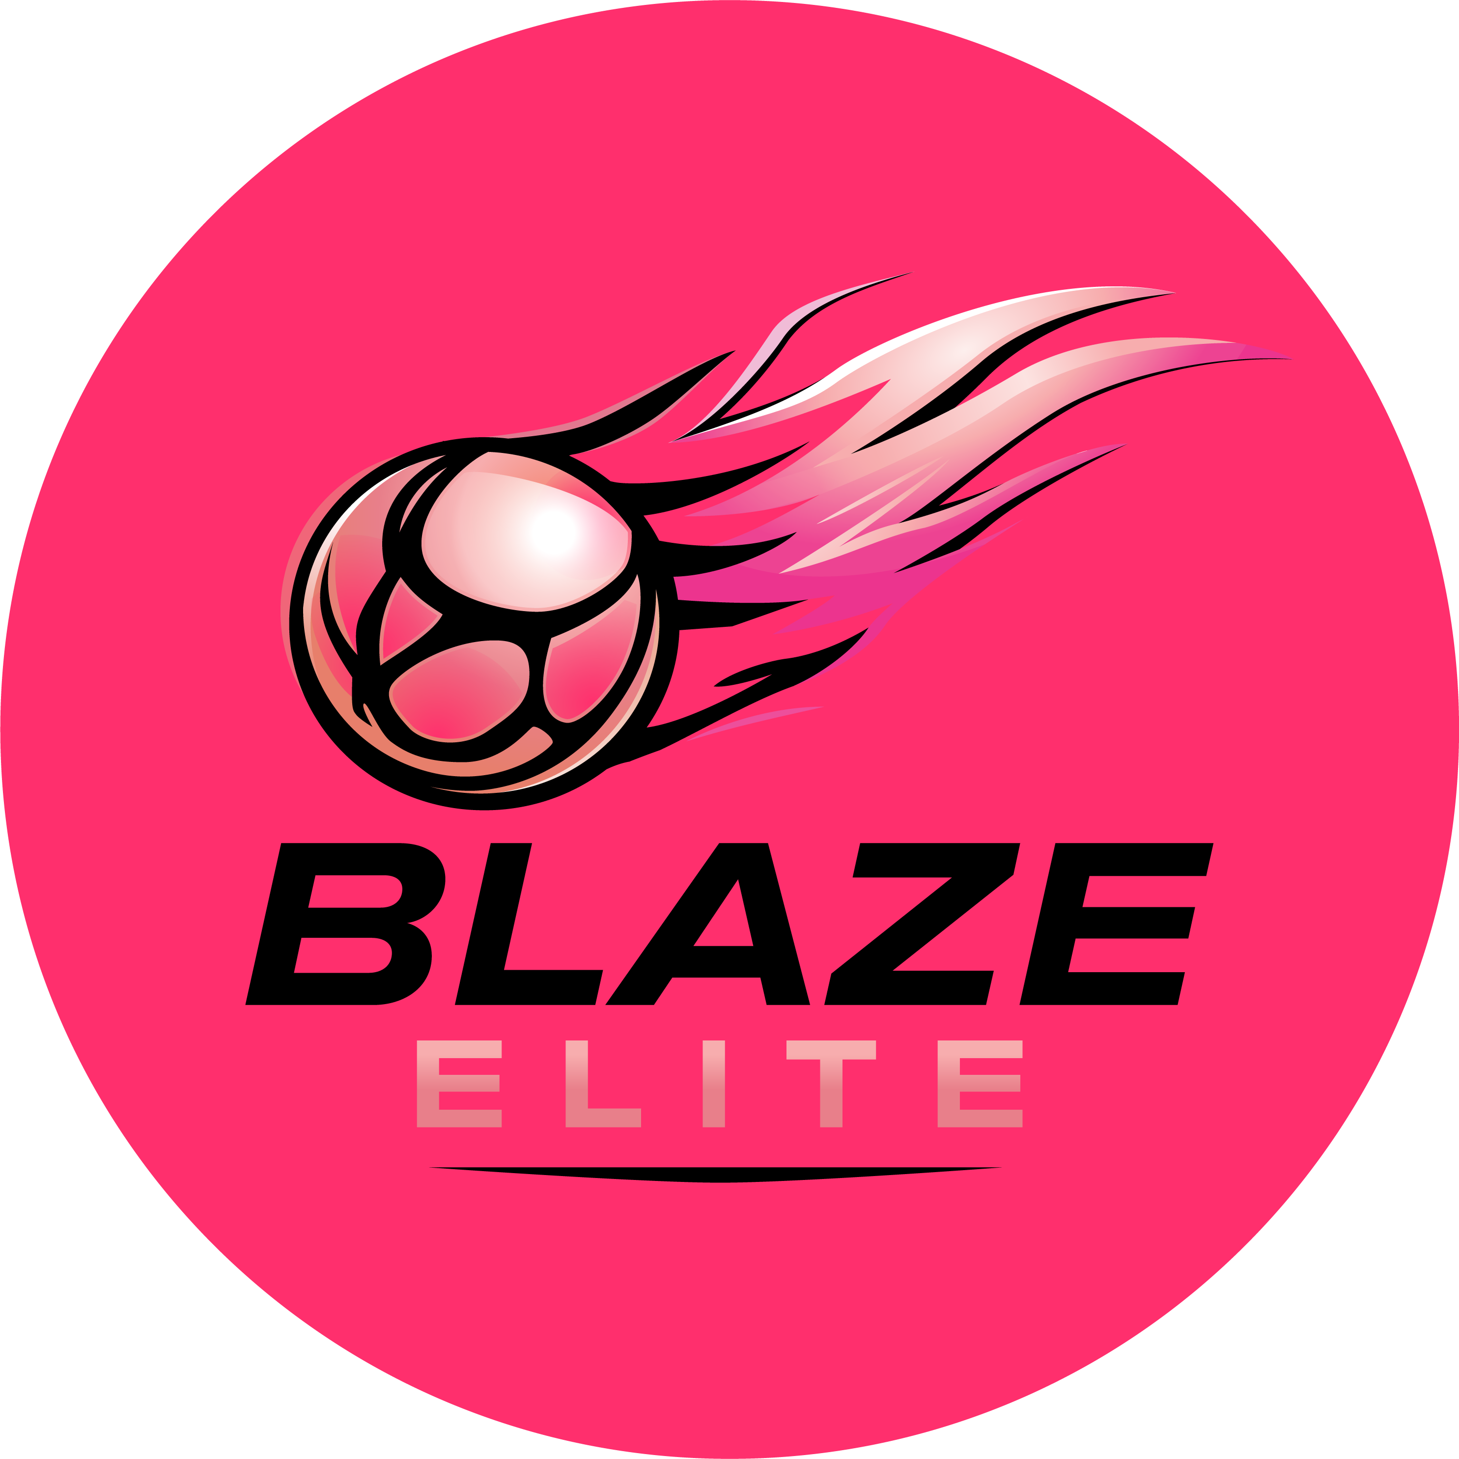

Health & Safety Policy
Blaze Elite Netball Club

1. Policy Statement
Blaze Elite is committed to providing a safe environment for all athletes, coaches, volunteers and spectators at training, fixtures and events.

2. Responsibilities
- The Head Coach is responsible for the safe delivery of training sessions.
- All venues used by Blaze Elite are risk assessed before use.
- Coaches and volunteers are responsible for reporting any hazard or safety concern immediately.

3. First Aid
A first aid trained coach and first aid kit are present at every training session and fixture.

4. Injury & Incident Reporting
Any injury or incident is recorded and reported to the Safeguarding & Welfare Officer. Parents/guardians are informed of any injury to their athlete as soon as reasonably possible.

5. Emergency Procedures
In the event of a medical emergency, qualified first aiders will administer emergency first aid in line with the consents given on the Athlete Registration & Annual Consent Form, and emergency services will be contacted where necessary.

